Case Study Report

### THANTHAI PERIYAR GOV ARTS AND SCIENCE COLLEGE

|  |  |
| --- | --- |
| **NM ID** | **NAME** |
| D4647E298E0A8EB81384100F0A | YOGESHWARAN B |

**Trainer Name:Uma maheswari**

**Crop production**

**ABSTRACT**

Crop production is a critical component of global agriculture, providing food, feed, fiber, and fuel for human consumption and industrial use. This paper presents an overview of key aspects of crop production, including cropping systems, agronomic practices, crop genetics, and emerging technologies. It examines the challenges faced by farmers, such as climate change, pests, diseases, and soil degradation, and explores sustainable solutions to enhance productivity and resilience.The role of biotechnology, precision agriculture, and digital farming in optimizing resource use and improving crop yields is discussed. Additionally, the importance of socioeconomic factors, policy frameworks, and market dynamics in shaping crop production systems is highlighted.By integrating scientific advancements with traditional knowledge and adopting holistic approaches, sustainable crop production practices can be promoted to ensure food security, environmental sustainability, and economic development worldwide.

**INDEX**

|  |  |  |
| --- | --- | --- |
| **Sr. No.** | **Table of Contents** | **Page No.** |
| **1** | **Chapter 1:**  **Introduction** | **4** |
| **2** | **Chapter 2:**  **Data Collection** | **6** |
| **3** | **Chapter 3:**  **Project Architecture** | **8** |
| **4** | **Chapter 4:**  **Modeling and Result** | **11** |
| **5** | **Conclusion** | **14** |
| **6** | **Future Scope** | **15** |

**CHAPTER 1**

**INTRODUCTION**

Crop production is a vital component of global agriculture, serving as the backbone of food systems worldwide.It encompasses the cultivation of a wide array of crops ranging from grains and vegetables to fruits and cash crops, providing sustenance for human consumption, animal feed, and industrial purposes. The process of crop production involves a series of interconnected activities, from land preparation and planting to harvesting and post-harvest management. Throughout the year, farmers engage in strategic planning, resource allocation, and risk management to optimize yields and meet the demands of growing populations.

## 1.1 Feature:

* Crop Diversity: Crop production involves the cultivation of a diverse range of crops, including grains, vegetables, fruits, legumes, oilseeds, and specialty crops. Diversity in crop selection helps mitigate risks associated with pests, diseases, and environmental stresses while providing nutritional and economic benefits.
* Site Selection and Land Management: Selecting suitable sites for crop production involves assessing factors such as soil type, topography, climate, and water availability. Effective land management practices, including soil conservation, erosion control, and land-use planning, help optimize crop productivity while minimizing environmental degradation.
* Crop Rotation and Diversification: Crop rotation involves alternating different crops in sequence on the same piece of land to improve soil health, reduce pest and disease pressure, and enhance nutrient cycling. Diversification of crops within a farming system provides resilience against market fluctuations and climate variability.

### 1.2 Advantages:

* Crop production contributes to food quality and safety by ensuring the availability of fresh, nutritious, and safe food products. Good agricultural practices, food safety standards, and quality assurance systems help maintain crop quality from farm to fork, safeguarding consumer health and confidence.
* For farmers, crop production serves as a primary source of income, livelihood, and economic stability. Successful crop production allows farmers to generate revenue from crop sales, enabling them to support their families, invest in farm inputs, and improve their quality of life.
* Crop production creates economic opportunities for farmers, rural communities, and agricultural industries. It generates income through crop sales, value-added processing, agribusinesses, and employment opportunities along the agricultural value chain.

### 1.3 Scope:

The scope of crop production encompasses a wide range of activities and considerations involved in cultivating plants for food, fiber, fuel, pharmaceuticals, and other purposes. It involves both traditional farming practices and modern agricultural techniques aimed at maximizing productivity, sustainability, and profitability. Here are some key aspects within the scope of crop production:

# CHAPTER 2

# Data Collection

### 2.1 Whole Years of data collection:

###### Pte-Season Preparation (Fall/Winter):

* Soil Sampling: Collect soil samples from fields to assess fertility, pH levels, and nutrient status.
* Crop Rotation Planning: Evaluate crop rotation options based on soil health, pest management, and agronomic considerations.
* farm machinery, irrigation systems, and equipment.
* Seed Selection: Research and select crop varieties based on performance data, market demand, and agronomic traits.
* Budgeting and Planning: Prepare budgets, crop plans, and planting Equipment Maintenance: Conduct maintenance checks and repairs on schedules for the upcoming growing season.

###### Early Spring (Pre-Planting):

* Field Mapping: Update field maps and boundary records using GPS and GIS technology.
* Land Preparation: Assess soil moisture and weather conditions for tillage, seedbed preparation, and weed control.
* Planting Decisions: Monitor weather forecasts and soil temperatures to determine optimal planting dates and conditions.
* Input Procurement: Purchase seeds, fertilizers, pesticides, and other inputs based on crop plans and agronomic recommendations.

###### Growing Season (Spring/Summer):

* Crop Monitoring: Conduct regular field scouting to monitor crop emergence, growth stages, pest infestations, and disease outbreaks.
* Irrigation Management: Monitor soil moisture levels and weather patterns to schedule irrigation and optimize water use efficiency.
* Nutrient Management: Implement fertilization plans based on soil test results, crop nutrient requirements, and growth stage assessments.
* Pest and Disease Monitoring: Monitor pest populations, weed pressure, and disease incidence to assess the need for pest control measures.
* Weather Tracking: Record daily weather data, including temperature, rainfall, humidity, and wind speed, to track growing degree days and weather patterns.

###### Harvest Season (Late Summer/Fall):

* Yield Monitoring: Install yield monitors on harvesting equipment to measure crop yields, moisture levels, and field performance.
* Harvest Operations: Conduct harvest operations efficiently, monitor grain quality, and record harvest data for yield analysis.
* Post-Harvest Handling: Store harvested crops properly to maintain quality, prevent spoilage, and minimize post-harvest losses.
* Economic Analysis: Calculate production costs, evaluate yield performance, and analyze market prices to assess profitability and financial performance.

###### sot-Harvest (Fall/Winter):

* Field Cleanup: Remove crop residues, manage cover crops, and prepare fields for winterization and soil conservation practices.
* Data Analysis: Analyze collected data on crop performance, input usage, pest pressures, and weather impacts to evaluate management practices and plan for the next growing season.
* Planning for Next Year: Reflect on lessons learned from the previous season, review crop rotation plans, and make adjustments to improve future crop production strategies.

## 2.2 Tools and Software used

## Tools:

* **Power Bi:** The main tool for this project is Power BI, which will be used to create interactive dashboards for real-time data visualization.
* **Power Query:** This is a data connection technology that enables you to discover, connect, combine, and refine data across a wide verify of sources

**Software Requirements:**

* Power Bi Desktop: This is a Windows application that you can use to create reports and publish them to Power Bi.
* Power Bi Service: This is an online Saar (Software as a Service) service that you use to publish reports, create new dashboards, and share insights.
* Power Bi Mobile: This is a mobile application that you can use to access your reports and dashboards on the go

# Chapter 3

# Project Architecture

## Planning Phase:

**Crop Selection:** Choose suitable crops based on factors like soil type, climate, market demand, and profitability.

**Field Mapping:** Use geographic information systems (GIS) to map fields, analyze topography, and plan irrigation systems.

**Resource Allocation:** Determine the required resources including seeds, fertilizers, pesticides, water, and labor.

## Preparation Phase:

**Land Preparation:** Plow, till, and level the land to create a suitable seedbed.

**Soil Preparation:** Test soil fertility and amend it as needed with fertilizers and organic matter.

**Infrastructure Setup:** Install irrigation systems, greenhouse structures, and other necessary infrastructure.

## Planting Phase:

**Sowing:** Plant seeds using appropriate methods such as direct seeding or transplanting seedlings.

**Crop Rotation:** Implement crop rotation strategies to improve soil health and prevent pest and disease buildup.

**Intercepting:** Plant complementary crops together to maximize space and resources.

## Cultivation Phase:

**Weed Management:** Employ techniques such as manual weeding, mulching, or herbicide application to control weed growth.

**Pest and Disease Control:** Monitor for pests and diseases regularly and use integrated pest management (IPM) strategies, including biological control and cultural practices.

**Fertilization:** Apply fertilizers based on soil nutrient needs and crop growth stages.

**Irrigation Management:** Manage irrigation scheduling to ensure proper water supply, avoiding both water stress and waterlogging.

## Monitoring and Maintenance Phase:

**Remote Sensing:** Utilize satellite imagery and drones for monitoring crop health, growth, and pest infestations.

**Data Analysis:** Analyze data collected from sensors, weather stations, and monitoring devices to make informed decisions.

**Crop Health Monitoring:** Monitor for signs of nutrient deficiencies, diseases, and stress factors.

**Adjustment:** Adjust cultivation practices as needed based on monitoring data and observations.

This architecture provides a framework for the entire crop production process, from planning and preparation to post-harvest activities, ensuring efficient and sustainable agriculture practices throughout the year.

# Chapter 4

# Modeling and Result

# Relations:

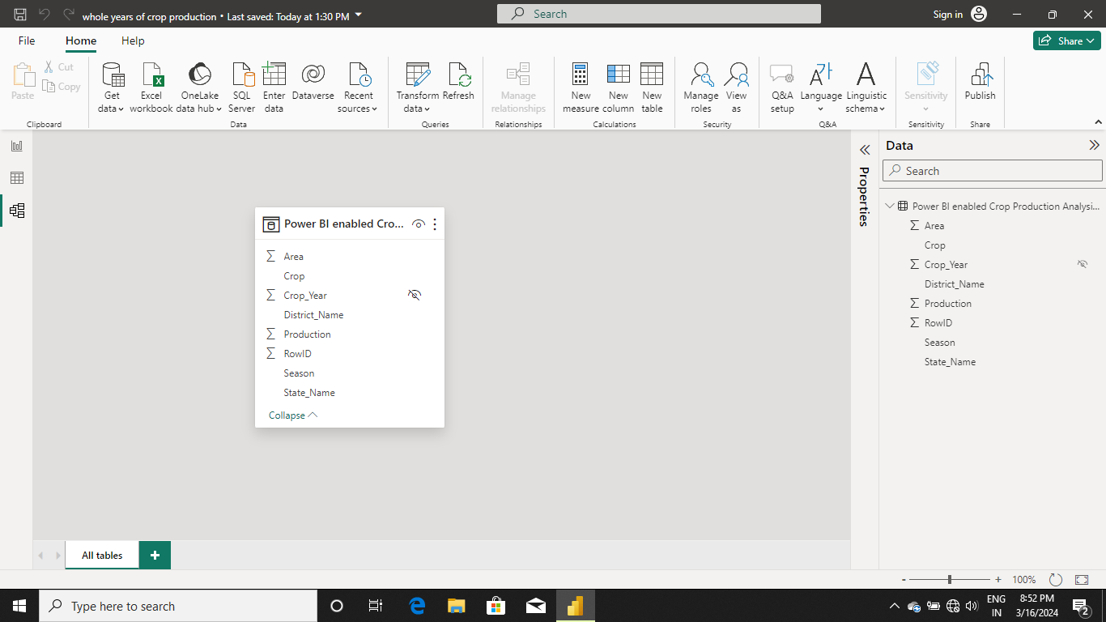

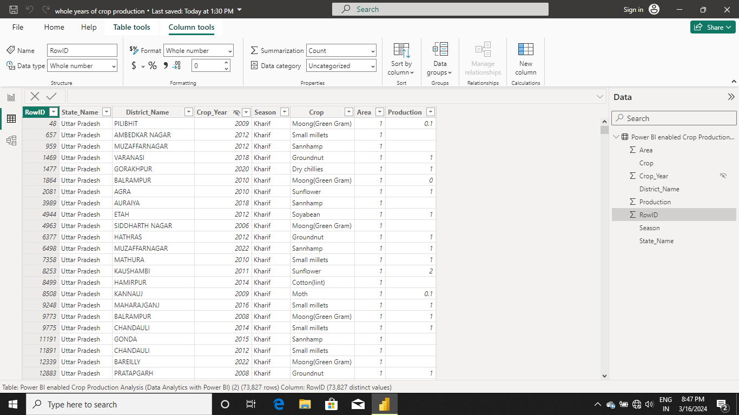

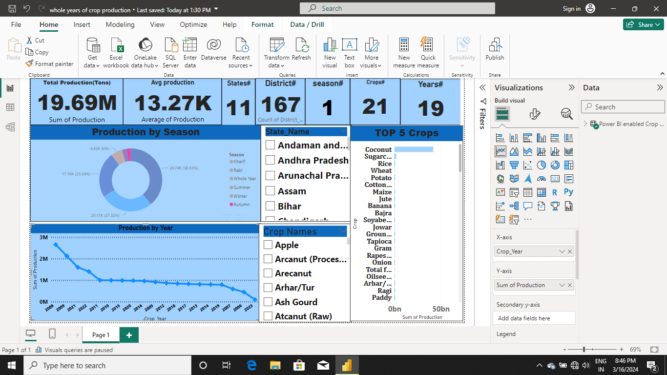

# CONCLUSION

The Power BI-enabled crop production analysis project has provided valuable insights into various aspects of crop production. Through data visualization and analysis, key patterns, trends, and correlations have been identified, aiding in decision-making processes for stakeholders in the agricultural sector. This project has not only enhanced understanding of crop production dynamics but also paved the way for more informed strategies to optimize yields, resource allocation, and sustainability practices

**FUTURE SCOPE**

The future scope of a Power BI-enabled crop production analysis project is promising. With advancements in data analytic and visualization, Power BI can offer deeper insights into crop production trends, optimize resource allocation, predict yields, and identify factors affecting crop growth. Integrating IoT sensors and satellite imagery can further enhance data accuracy, enabling real-time monitoring and decision-making for farmers and policymakers. Additionally, leveraging machine learning models within Power BI can forecast crop yields and mitigate risks associated with climate change and market fluctuations, making it a valuable tool for sustainable agriculture